**Assignment #1**

* 1. **Task 1**

In your terminal, run >> conda info

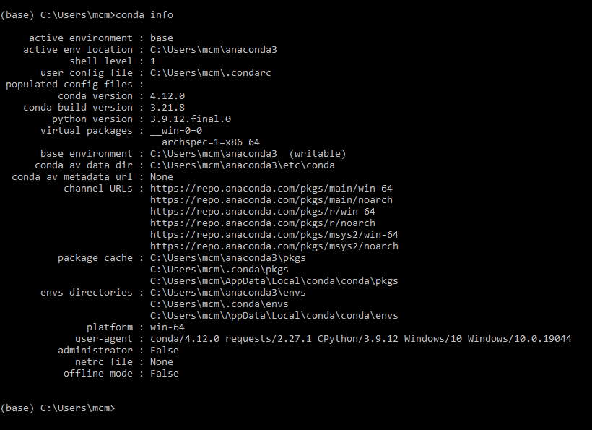

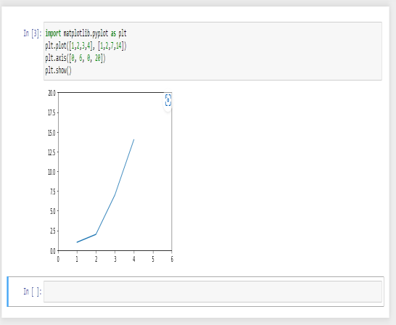**3.1 Task 2**

Run the following script in IPython and paste the figure created by the script into your report

import. matplotlib.pyplot as plt

plt.plot([1,2,3,4], [1,2,7,14])

plt.axis([0, , 6, 0, 20])

plt.show()

**3.2 Task 3**

Use Matplotlib to create a figure of your choice in IPython. Paste your code and figure into your report

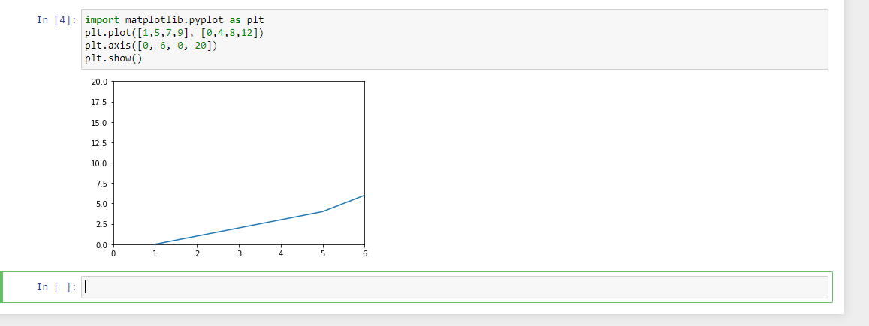

**4.1 task 4**

Register for a student account here for free private repository access for future projects and go through these tutorials. insert a screenshot of your user page in github in your report.

